
People's Democratic Republic of Algeria
Ministry of Higher Education and Scientific Research

University of Science and Technology Houari Boumediene

Faculty of Electrical Engineering
Department of Electronics

Mini Project Report M1
Master's in Electronic Instrumentation

Project Topic
Design and Implementation of a Programmable Instrumentation Amplifier Module in SMD

Proposed by: | Presented by:
Prof. ATTARI Mokhtar | Sous Groupe 5 Ref: P

Project Manager | KALLI Dalia
Member 1 | LELLOUCHE Malak
Member 2 | KANOUN Wissam
Member 3 | YAICHE Lasmaa
Member 4 | ICHIR Yasmine
Member 5 | HAMIDI Sonia

Mini-project prepared and carried out within the:

Faculty of Electrical Engineering, University of Science and Technology Houari Boumediene
URL : http://www.fge.usthb.dz, USTHB/FGE, Year : 2024/2025
Abstract:
This project focuses on the design and implementation of a programmable gain instrumentation amplifier. The circuit is based on the use of three OP07 operational amplifiers, known for their low noise and high precision, combined with MOSFETs for electronic gain switching. A digital decoder is integrated to control the selection of precision resistors that determine the system’s gain. The main objective is to allow precise and electronic adjustment of the amplifier gain without mechanical intervention, facilitating its integration into automated systems and improving instrumentation flexibility. Component choices were made considering constraints of stability, linearity, and low thermal drift. The printed circuit board was designed using the EasyEDA software, and the implementation uses through-hole components due to limited availability of SMD parts. The conducted tests show good agreement between experimental results and theoretical predictions, thereby validating the design. This work offers an efficient and modular solution for applications requiring precise and adjustable amplification, particularly in the fields of measurement and signal processing.

Keywords:

Instrumentation amplifier, Op-Amp, MOSFET, ArduinoUno, SMD components

Résumé :
Ce projet porte sur la conception et la réalisation d’un amplificateur d’instrumentation à gain programmable. Le circuit est basé sur l’utilisation de trois amplificateurs opérationnels OP07, reconnus pour leur faible bruit et leur grande précision, associés à des MOSFET pour la commutation électronique du gain. Un décodeur numérique est intégré afin de contrôler la sélection des résistances de précision qui déterminent le gain du système. L’objectif principal est de permettre un réglage précis et électronique du gain de l’amplificateur sans intervention mécanique, ce qui facilite son intégration dans des systèmes automatisés et améliore la flexibilité de l’instrumentation. Le choix des composants a été effectué en tenant compte des contraintes de stabilité, de linéarité et de faible dérive thermique. La conception du circuit imprimé a été réalisée via le logiciel EasyEDA, et la mise en œuvre utilise des composants traversants en raison de la disponibilité limitée des composants SMD. Les essais effectués montrent une bonne concordance entre les résultats expérimentaux et les prévisions théoriques, validant ainsi la pertinence du montage. Ce travail offre une solution efficace et modulaire pour des applications nécessitant une amplification précise et ajustable, notamment dans le domaine de la mesure et du traitement du signal.

Les mots clés :

Ampli d'instrumentation, AOP, MOSFET, arduino uno, composants SMD
ملخص

يركز هذا المشروع على تصميم وتنفيذ مضخم أجهزة قياس ذو كسب قابل للبرمجة. يعتمد الدائرة على استخدام ثلاثة مضخمات عمليات OP07، المعروفة بانخفاض الضوضاء ودقتها العالية، بالإضافة إلى استخدام موسفتات (MOSFET) للتحكم الإلكتروني في تبديل الكسب. كما تم دمج جهاز فك ترميز رقمي للتحكم في اختيار المقاومات الدقيقة التي تحدد كسب النظام. الهدف الرئيسي هو تمكين ضبط دقيق وإلكتروني لكسب المضخم دون تدخل ميكانيكي، مما يسهل دمجه في الأنظمة المؤتمتة ويعزز مرونة الأجهزة القياسية. تم اختيار المكونات مع مراعاة متطلبات الاستقرار، الخطية، وانخفاض الانجراف الحراري. تم تصميم لوحة الدائرة المطبوعة باستخدام برنامج EasyEDA
، وتم تنفيذ المشروع باستخدام مكونات ذات تركيب من خلال الثقب (Through-Hole) نظرًا لتوفر محدود لمكونات SMD. أظهرت الاختبارات التي أجريت توافقًا جيدًا بين النتائج التجريبية والتوقعات النظرية، مما يؤكد صحة التصميم. يقدم هذا العمل حلاً فعالاً ومرنًا للتطبيقات التي تتطلب تضخيماً دقيقًا وقابلاً للتعديل، خاصة في مجالات القياس ومعالجة الإشارة.
الكلمات الدالة

أردوينوأونو،مكبر أداة القياس، مضخم تشغيلي، موسفيت مكونات، SMD

Index:

Introduction

Chapter 1: states of art

1.Introduction

2. Operational Amplifiers (Op-Amps):
2.1 Definition and Operating Principle
2.2 Mathematical Model of the Ideal Op-Amp

2.3 Basic Configurations

3. Instrumentation Amplifiers
3.1 Definition

3.2 Typical 3-Op-Amp Instrumentation Amplifier Circuit

3.3 Advantages

4. Applications of Instrumentation Amplifiers

5. Surface-Mount Device (SMD) Technology

5.1 Definition

5.2 Advantages

5.3 Examples of Op-Amps in SMD Packages

6. conclusion

Chapter 2: Electronic Components and Design Software

- Introduction

2. Hardware Part:
2.1 Arduino Uno Board
2.2 ATmega328P
2.3 OP07 Operational Amplifier
2.4 The 74HC138 Decoder
2.5 IRL540NS MOSFET
2.6 Linear Voltage Regulators 7805 and 7808
2.7 Resistor
2.8 Capacitor
2.9 Relay

3. Software part
3.1 Arduino uno
3.2 Easy Eda software
3.3 proteus

Chapter 3: Design, Implementation, and Testing
- Introduction:
- System overview
- 12 v symmetric Power Supply Description
- Block diagram
- Organizational chart
- Electronic Board Design

General Introduction:
In a world where miniaturization, precision, and flexibility of electronic systems have become essential requirements, the development of compact and high-performance analog modules represents a major technological challenge. Among these modules, the instrumentation amplifier plays a central role in measurement, control, and low-level signal processing systems. It enables accurate amplification of low-amplitude differential signals while rejecting common-mode disturbances, thereby ensuring optimal measurement quality—crucial in fields as diverse as biomedical engineering, industrial automation, and scientific instrumentation.
This work fits into this context and aims to design and implement a programmable instrumentation amplifier module, based on an OP07 operational amplifier mounted using SMD (Surface-Mount Device) technology. The OP07 was chosen for its excellent precision characteristics, including low offset voltage and minimal thermal drift, making it an ideal candidate for high-fidelity signal processing applications.
The programmable gain aspect of the amplifier is a major advantage, allowing dynamic adjustment of the module’s performance to suit different application requirements. To achieve this, a gain-setting resistance adjustment solution will be integrated into the circuit, while maintaining a fully analog structure without the use of microcontrollers in the initial version—thus ensuring simplicity and robustness.
This thesis presents all the stages leading to the realization of this module: from the theoretical analysis of the instrumentation amplifier’s operation, through the design of the electronic schematic and the selection of SMD components, to the manufacturing of the printed circuit board (PCB) and the experimental validation of the prototype.
This project is also part of a pedagogical and experimental approach, offering a practical framework to apply knowledge in analog electronics, printed circuit design, and applied electronic instrumentation.

Chapter 1: State of the Art
1.1 Introduction:
Analog electronics forms the fundamental basis for many applications in signal processing, measurement, control, and physical signal conversion. Operational amplifiers (Op-Amps), central components in this field, are ubiquitous in modern circuits. This chapter introduces Op-Amps, their extension into instrumentation amplifiers, and their implementation in Surface-Mount Device (SMD) technology, relevant for practical projects.[1][2]

2. Operational Amplifiers (Op-Amps):

2.1 Definition and Operating Principle
An operational amplifier is an analog electronic component designed to amplify the voltage difference between two inputs (non-inverting + and inverting −). Ideally, it has infinite open-loop gain, infinite input impedance, and zero output impedance.[3]

2.2 Mathematical Model of the Ideal Op-Amp:

$$V_{out}=A_{0}(V_{+}-V_{-})$$

2.3 Basic Configurations
- Voltage follower (buffer)
- Inverting amplifier
- Non-inverting amplifier
- Integrator and differentiator

Example: Inverting Amplifier
The output voltage for an inverting amplifier is given by:
$V_{out}=-\frac{R_{ f}}{R_{in}}V_{in}$ ​(2)
3. Instrumentation Amplifiers:

3.1 Definition:
An instrumentation amplifier is an analog circuit designed to amplify weak differential signals while rejecting common-mode noise. It is widely used in measurement systems such as biomedical and industrial applications.[4]

3.2 Typical 3-Op-Amp Instrumentation Amplifier Circuit:
The circuit uses:
- Two Op-Amps (A1 and A2) in non-inverting configuration for initial gain stages.
- A third Op-Amp (A3) as a difference amplifier.

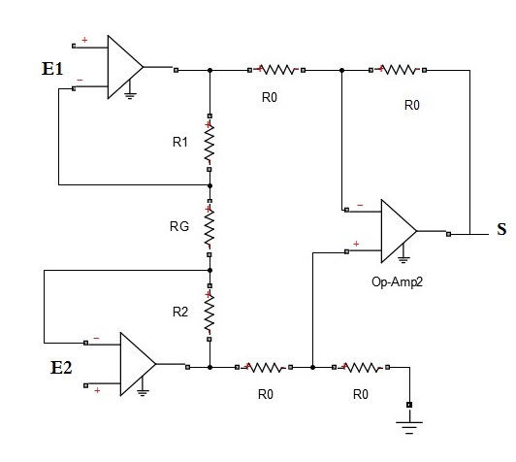

The intermediate voltages are:
$V_{A1}=V_{1}\left(1+\frac{2R}{R_{G}}\right)$ (3)
$V_{A2}=V_{2}\left(1+\frac{2R}{R_{G}}\right)$ (4)
The output voltage is:
$V_{out}=V_{A2}-V_{A1}$ (5)

Therefore, the overall gain is:
$V_{out}=\left(1+\frac{2R}{R_{G}}\right)\left(V_{2}-V_{1}\right)$ (6)
The Common Mode Rejection Ratio (CMRR) is defined as:
${CMRR}_{dB}=20\log_{10}\left(\frac{A_{diff}}{A_{cm}}\right)$ (7)

3.3 Advantages
- High input impedance
- Excellent common-mode noise rejection
- Easy gain adjustment
- Used in precision measurement applications

4. Applications of Instrumentation Amplifiers
- Biomedical: ECG, EMG, EEG
- Industrial instrumentation: temperature and pressure sensors
- Embedded systems: battery monitoring, low current detection.

5. Surface-Mount Device (SMD) Technology:

5.1 Definition:
SMD components are mounted directly on the surface of printed circuit boards, avoiding drilling holes and enabling compact, automated designs.

5.2 Advantages
- Space saving
- Better high-frequency performance
- Reduced parasitic inductances
- Suitable for automated industrial production

5.3 Examples of Op-Amps in SMD Packages
- OPA2134UA (Texas Instruments)
- AD620AR (Analog Devices)

6. Conclusion:
This chapter has established fundamental knowledge on operational amplifiers and their evolution towards instrumentation amplifiers. Due to their precision and noise robustness, instrumentation amplifiers are indispensable in measurement applications. The introduction of SMD technology highlights the modern trends towards miniaturization and efficient industrial production, relevant to the practical scope of this project.

Chapter 2: Electronic Components and Design Software

1.Introduction:
In this chapter, we present our instrumentation amplifier project, designed using three OP07 operational amplifiers in SMD (Surface-Mount Device) technology. This choice allows for a compact, precise circuit suitable for modern signal acquisition applications. The chapter is divided into two complementary parts: a hardware section, which describes the essential components used in the circuit (amplifiers, MOSFETs, decoder, Arduino Uno), and a software section, which covers the control program developed to dynamically adjust the amplifier’s gain. The overall objective is to implement a system capable of reliably processing low-level signals while allowing flexible adjustment through digital control.

2.Hardware Part:
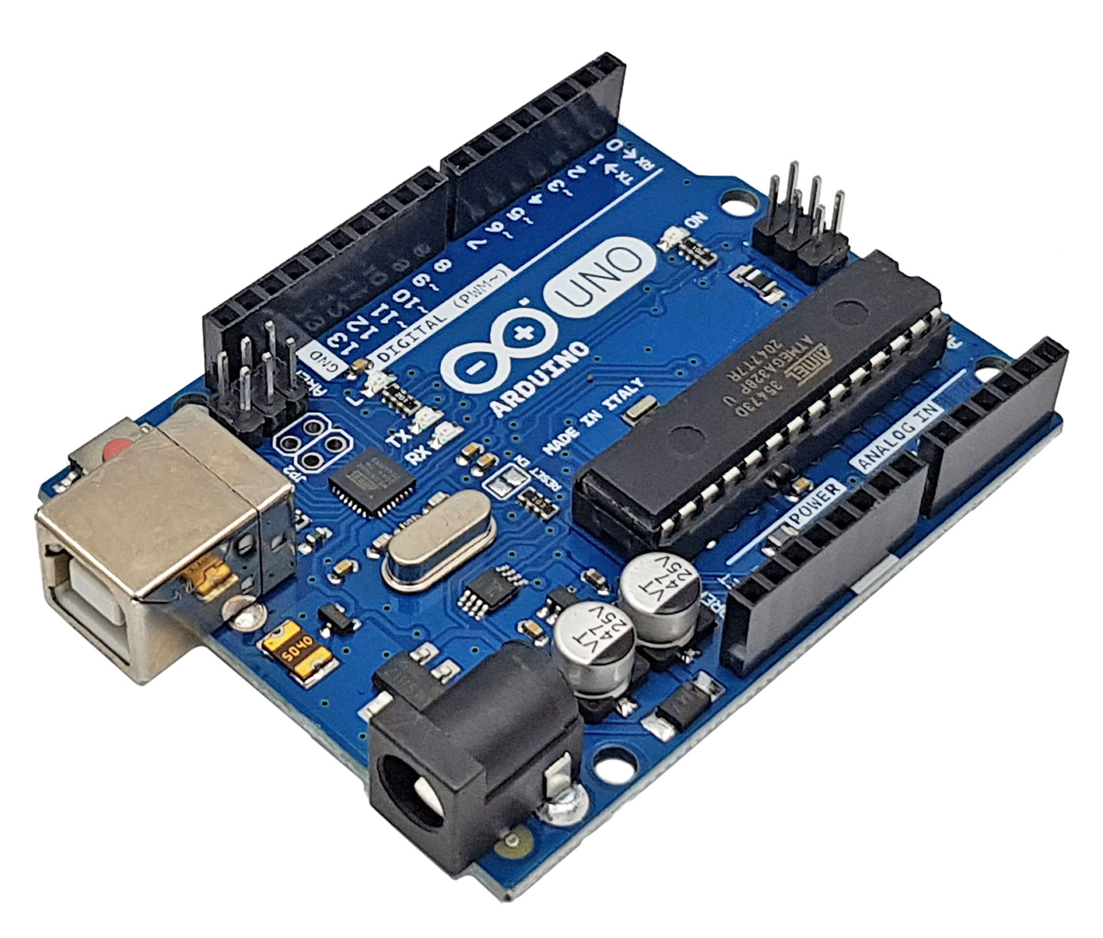
2.1 Arduino Uno Board:

The Arduino Uno board is the main component of our project, as it handles data processing and control. "Uno" means "one" in Italian and was chosen to mark the release of Arduino software (IDE) version 1.0, which was the reference version of Arduino, now evolved into more recent versions. The Arduino Uno is a microcontroller board based on the ATmega328. It can be powered via a USB connection, an external power source, or through an AC-to-DC adapter or a battery. It has 14 digital input/output pins (6 of which can be used as PWM outputs), 6 analog inputs, a 16 MHz quartz crystal oscillator, a USB connection, a power jack, an ICSP header, and a reset button. Table II-1 provides a summary of its specifications. Moreover, Arduino boards are equipped with standardized connectors for attaching compatible modules called Shields. These are circuit boards approximately the same size as the Arduino and are stacked on top of the board using these connectors. They offer hardware extensions that allow the addition of new functionalities to the project.

Parameter | Value
Microcontroller | ATmega328
Clock Frequency | 16 MHz
Operating Voltage | 5V
Recommended Supply Voltage | 7–12V
Supply Voltage Limits | 6–20V
Digital I/O Pins | 14 (6 of which can be used as PWM outputs, marked with the tilde symbol)
Analog Input Pins | 6 (can also be used as digital I/O pins)
Max Current per I/O Pin (5V) | 40 mA (Note: 200 mA max total for all I/O pins combined)
Max Current for 3.3V Output | 50 mA
Max Current for 5V Output (USB) | 500 mA max via USB port
Flash Program Memory | 32 KB (ATmega328), of which 0.5 KB is used by the bootloader
SRAM (Volatile Memory) | 2 KB (ATmega328)
EEPROM (Non-Volatile Memory) | 1 KB (ATmega328)
Interface | USB (used to power the board and upload programs)
External Power Supply | Jack
Dimensions | 6.86 cm × 5.3 cm
Table II-1: Main Characteristics of the Arduino Uno Board

2.2. ATmega328P:
The ATmega328p is one of a series of 8-bit AVR MCUs built by Microchip that is relatively easy to implement for specific function devices and products. The chip has several features, including low power consumption and fast processing speed, that promote its use in many applications, as listed below.
Common AT328p Applications :
- Industrial equipment control
- Motor control
- Power regulation
- Switch mode power systems
- Commercial product embedded systems
- Digital processing
- Analog signal acquisition and processing
- Peripheral interface
- Display devices
In addition to the applications listed above, the ATmega328p is probably most often used for development with Arduino boards; such as the popular UNO. [8]
2.3. OP07 Operational Amplifier:
The OP07 has very low input offset voltage (75 μV maximum for OP07E) that is obtained by trimming at the wafer stage. These low offset voltages generally eliminate any need for external nulling. The OP07 also features low input bias current (±4 nA for the OP07E) and high open-loop gain (200 V/mV for the OP07E). The low offset and high open-loop gain make the OP07 particularly useful for high gain instrumentation applications. PIN CONFIGURATION VOS TRIM 1 8 VOS TRIM –IN 2 7 V+ +IN 3 6 OUT V– 4 5 NC OP07 NC = NO CONNECT 00316-001 Figure 1. The wide input voltage range of ±13 V minimum combined with a high CMRR of 106 dB (OP07E) and high input impedance provide high accuracy in the noninverting circuit configuration. Excellent linearity and gain accuracy can be maintained even at high closed-loop gains. Stability of offsets and gain with time or variations in temperature is excellent. The accuracy and stability of the OP07, even at high gain, combined with the freedom from external nulling have made the OP07 an industry standard for instrumentation applications. The OP07 is available in two standard performance grades. The OP07E is specified for operation over the 0°C to 70°C range, and the OP07C is specified over the −40°C to +85°C temperature range. The OP07 is available in epoxy 8-lead PDIP and 8-lead narrow SOIC packages. For CERDIP and TO-99 packages and standard microcircuit drawing (SMD) versions, see the OP77.

Features:
Low VOS: 75 μV maximum
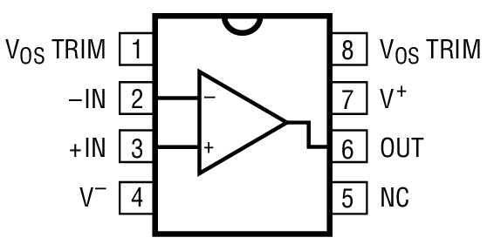
Low VOS drift: 1.3 μV/°C maximum
Ultrastable vs. time: 1.5 μV per month maximum
Low noise: 0.6 μV p-p maximum
Wide input voltage range: ±14 V typical
Wide supply voltage range: ±3 V to ±18 V 125°C temperature-tested dice.

2.4. The 74HC138 Decoder:
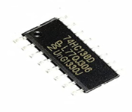
The 74HC/HCT138 are high-speed Si-gate CMOS devices and are pin compatible with low power Schottky TTL (LSTTL). They are specified in compliance with JEDEC standard no. 7A. The 74HC/HCT138 decoders accept three binary weighted address inputs (A0, A1, A2) and when enabled, provide 8 mutually exclusive active LOW outputs (Y0 to Y7). The “138” features three enable inputs: two active LOW (E1 and E2) and one active HIGH (E3). Every output will be HIGH unless E1 and E2 are LOW and E3 is HIGH. This multiple enable function allows easy parallel expansion of the “138” to a 1-of-32 (5 lines to 32 lines) decoder with just four “138” ICs and one inverter. The ”138” can be used as an eight output demultiplexer by using one of the active LOW enable inputs as the data input and the remaining enable inputs as strobes. Unused enable inputs must be permanently tied to their appropriate active HIGH or LOW state. The ”138” is identical to the “238” but has inverting outputs.
Features:
• Demultiplexing capability
• Multiple input enable for easy expansion
• Ideal for memory chip select decoding
• Active LOW mutually exclusive outputs
• Output capability: standard
• ICC category: MSI

2.5 IRL540NS MOSFET:
Fifth Generation HEXFETs from International Rectifier utilize advanced processing techniques to achieve extremely low on-resistance per silicon area. This benefit, combined with the fast switching speed and ruggedized device design that HEXFET Power MOSFET sare well known for, provides the designer with an extremely efficient and reliable device for use in a wide variety of applications .The D2Pak is a surface mount power package capable of accommodating die sizes up to HEX-4.
It provides the highest power capability and the lowest possible on-resistance in any existing surface mount package. TheD2Pak is suitable for high current applications because of its low internal connection resistance and can dissipate upto 2.0W in a typical surface mount application. The through-hole version (IRF540NL) is available for low-profile applications
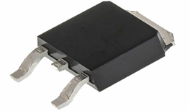
Features:
- N-Channel Power MOSFET
- Maximum Drain-Source Voltage (Vds): 100 V
- Maximum Continuous Drain Current (Id): 36 A
- Maximum Gate-Source Voltage (Vgs): ±16 V
- Gate Threshold Voltage (Vgs(th)): Approximately 2 V
- Maximum Power Dissipation (Pd): 140 W
- Maximum Junction Temperature (Tj): 175 °C
- Total Gate Charge (Qg): 74 nC (max)
- Rise Time (tr): 81 ns
- Output Capacitance (Coss): 350 pF
- On-State Resistance (Rds(on)): 0.044 Ω (typical)
- Package: TO-263 (D2Pak), surface mount
- Logic-level compatible (can be driven by 5 V logic)
- Fully avalanche rated with fast switching capability
- RoHS compliant

2.6. Linear Voltage Regulators 7805 and 7808:
The 7805 and 7808 are popular linear voltage regulators widely used to provide stable and regulated DC voltage outputs in electronic circuits.
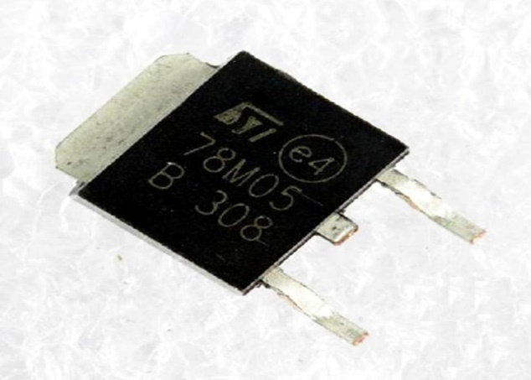
7805 Voltage Regulator:
The 7805 is a popular linear voltage regulator IC that is commonly used to provide a stable and regulated +5V DC output voltage from an unregulated DC power source. Here are some key features and characteristics of the 7805 voltage regulator
FEATURES :
Internal Thermal Overload Protection.
Internal Short Circuit Current Limiting.
Output Current up to 1.5A.
Satisfies IEC-65 Specification. (International Electronical Commission).
Package is TO-220AB.
7808 Voltage Regulator:
Features :
• Output Current up to 1 A
• Thermal Overload Protection
• Short Circuit Protection
• Output Transistor Safe Operating Area Protection[13]

2.7 Resistors:

Resistors are fundamental passive components used in all electronic circuits, and they play a critical role in the design and performance of instrumentation amplifiers. In this project, Surface-Mount Device (SMD) resistors are selected due to their compact size, high precision, and suitability for modern analog circuit de

2.8 capacitor:
Capacitors are essential passive components in electronic circuits, playing a vital role in filtering, decoupling, and voltage stabilization. In our instrumentation amplifier project, capacitors are used to ensure circuit stability and reduce unwanted noise.
2.9 Relay:
A relay is an electromechanical component that allows control of an electrical circuit by opening or closing electrical contacts using an electrical signal. It acts as an electromagnetic switch.

3.Software part:

II.3.1 Arduino IDE:

The software used to program Arduino modules is a cross-platform Java application (running on any operating system). It is based on an Integrated Development Environment (IDE) that allows users to write, compile, and upload code to development boards. The programming language is a simplified variant of C/C++, tailored for use with the board, its input/output features, and the associated libraries. Anyone familiar with these languages can easily develop programs on Arduino platforms.

II.3.2 EasyEDA Software:


EasyEDA is an easy-to-use online software for circuit design, circuit simulation, and printed circuit board (PCB) design. It offers a user-friendly interface and advanced features for both electronics enthusiasts and professionals.

II.3.3 Proteus:
Proteus was developed by Center for Electronics and is a software dedicated to electronics. This Proteus software suite includes main programs that enable Computer-Aided Design (CAD) in the field of electronics. The suite consists of four main software components: ISIS, ARES, PROSPICE, and VSM [14]. Many companies and educational institutions (including high schools and universities) use this software, which is well-known in the electronics industry. Besides its popularity, Proteus offers several advantages: A set of software tools that are fast, easy to understand, and simple to use. Efficient technical support. The virtual prototyping tool reduces hardware and software costs during project design [14].

Conclusion:
This chapter presented the hardware components (SMD op-amps, precision resistors, capacitors, MOSFETs) and software tools (Arduino, EasyEDA) used in the design of our instrumentation amplifier. All elements were selected to ensure compactness, stability, and precision. This solid foundation sets the stage for the next chapter, which focuses on the practical implementation steps of the project.

Chapter 3: Design, Implementation, and Testing

1. Introduction:
This chapter presents the different stages involved in the implementation of our project, from the design of the functional diagram to the final testing of the circuit. First, we will detail the system design, including the selection of electronic components such as operational amplifiers (op-amps), MOSFETs, as well as other passive and active components. The implementation section will then describe the printed circuit board (PCB) design process, carried out using the online software EasyEDA, followed by the PCB manufacturing and the assembly of components. Initially, we had planned to use surface-mount devices (SMD), but due to their unavailability, we chose to build our project using standard through-hole components. Finally, the testing section will present the various methods employed to verify the proper operation of the circuit, by measuring electrical signals at key points and comparing the results with theoretical predictions. This comprehensive approach allowed us to transform a theoretical concept into a reliable physical prototype, while respecting the technical and functional constraints defined from the outset.
2.System Overview:
The circuit represents a programmable-gain instrumentation amplifier. Its architecture is composed of four functional blocks, as follows:
• The first subsystem, forming the core of the architecture, is a classical instrumentation amplifier based on a three-op-amp topology using OP07 operational amplifiers.
• The second block, which is digital in nature, includes an ATmega328P microcontroller, a 3-to-8 line decoder (74HC138), and four N-channel MOSFET transistors (BS170), responsible for gain switching.
• A linear voltage regulation module provides a stabilized +5 V DC supply, required for the reliable operation of the digital logic circuits.
• Finally, a ±12 V symmetrical power supply is dedicated to the analog stages, particularly the OP07 amplifiers, ensuring maximum signal swing and optimal performance.
Global Architecture of the System :
The diagram above illustrates the overall hardware architecture of the system:
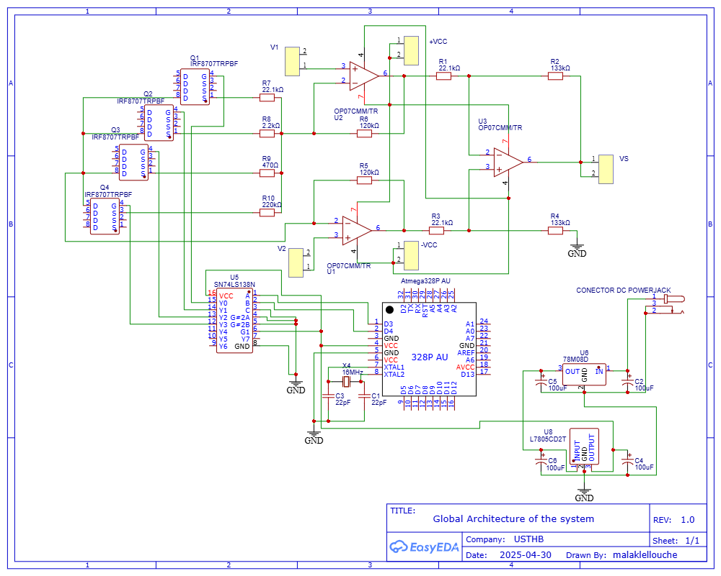
Functional Description:

1. Dynamic Gain Programming in an Instrumentation Amplifier
In this project, gain variation in the instrumentation amplifier is achieved through a resistor network switched by MOSFETs acting as electronic switches. This architecture enables digitally programmable gain, offering fast and precise adaptability to measurement conditions.

2.Gain Control Architecture
The gain network consists of four resistors, each connected in series with an N-channel MOSFET. Only one MOSFET is activated at any given time, inserting a single resistor into the amplifier’s feedback loop.
The MOSFETs are controlled via a 3-to-8 line decoder, driven by a microcontroller (MCU). Since only four gain levels are implemented, the most significant input of the decoder is held low, effectively enabling only four active outputs.

3. Gain Selection Algorithm
Gain selection is dynamically managed by the microcontroller based on the differential input voltage (Vdiff) between inputs V1 and V2. The following table summarizes the selection logic:
Vdiff Range (V) | Selected Resistance (R) | Corresponding Gain | Activated MOSFET
Vdiff < 0.01 | 220 Ω | ≈ 1200 | MOSFET N°4
0.01 ≤ Vdiff < 0.04 | 470 kΩ | ≈ 511 | MOSFET N°3
0.04 ≤ Vdiff < 0.07 | 2.2 kΩ | ≈ 110 | MOSFET N°2
Vdiff ≥ 0.07 | 22.1 kΩ | ≈ 12 | MOSFET N°1

4. Signal Routing and Power Supply
- Input signals: V1 and V2 are applied via dedicated jumper straps.
- Power supply: The amplifier is powered using a ±12 V symmetric supply. The control logic (MCU + decoder) is powered by a regulated +5 V source.
- Output: The amplified output signal is available at a separate output strap for measurement or further processing.

3.±12V Symmetric Power Supply Description:
This circuit provides a ±12V symmetric DC power supply from a standard 230V AC mains input. It consists of the following stages:
- Step-Down Transformer :
The circuit is powered by a 230V AC mains source , the transformer converts the 230V AC mains voltage down to 12V AC, while providing galvanic isolation between the mains and the low-voltage section of the circuit.
- Rectification (Bridge Rectifier):
A diode bridge rectifier converts the AC voltage into a full-wave rectified DC voltage.
- Filtering (C1, C2):
Electrolytic capacitors (1000 µF / 50V) smooth out the rectified voltage to reduce ripple.C1 and C2 filter the voltage before regulation.
- Voltage Regulation ( LM7812 and LM7912):
  - The LM7812 provides a stable +12V output.
  - The LM7912 provides a stable -12V output.
These linear voltage regulators ensure constant output voltages despite variations in input voltage or load.
- Output Terminals (B1 and B2):
The circuit delivers two DC voltages:
  - +12V (B1)
  - -12V (B2)
with a common GND reference.
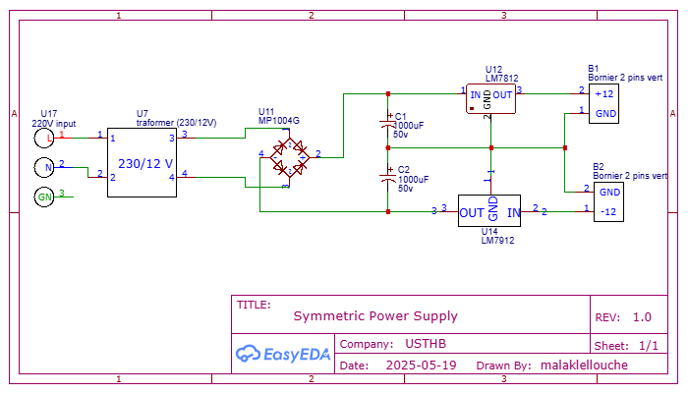
4.Block diagram :
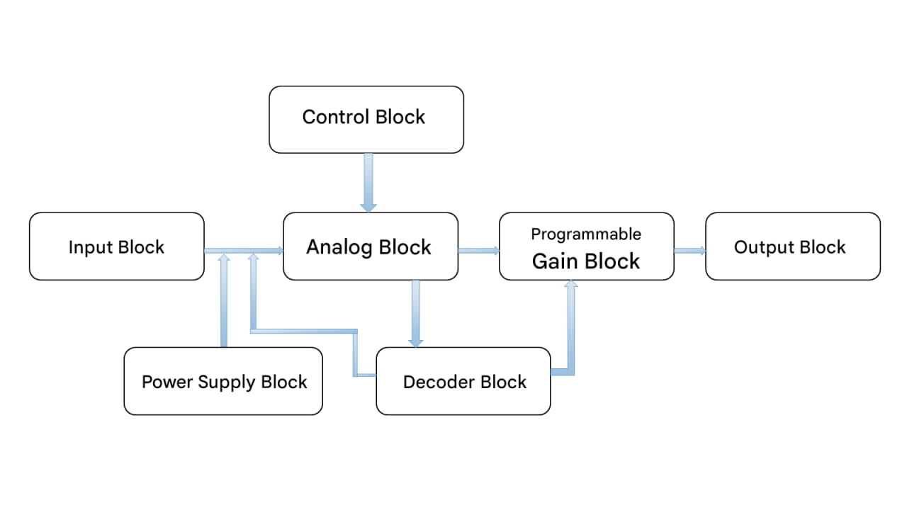
5.Organizational chart :
The process begins with an initialization step, where serial communication is started and the control pins (D2 and D3) are configured as outputs to drive the address inputs A0 and A1 of the 74HC138 decoder. Then, the system enters a repetitive loop. In each cycle, the Arduino reads the analog voltage on input A0 and converts it into volts. This voltage is then displayed on the serial monitor.
The program compares the measured voltage to three defined thresholds: 0.01 V, 0.04 V, and 0.07 V. Based on the result of this comparison, it selects a specific gain: if the voltage is less than 0.01 V, it activates gain G4 (1200); between 0.01 V and 0.04 V, gain G3 (511.63); between 0.04 V and 0.07 V, gain G2 (110); and if the voltage is greater than or equal to 0.07 V, gain G1 (11.85). Each gain corresponds to a specific combination of address bits that activates one output of the 74HC138 decoder. Finally, the program waits 2 seconds before restarting the cycle.
6. Electronic Board Design :
PCB Design Steps:
1. Schematic Design: We begin by creating an electronic schematic of the circuit in EasyEDA. Components are placed and connected using appropriate connections.
2. PCB Layout Design: Once the schematic is complete, we move on to the PCB layout. Using EasyEDA's integrated PCB design tool, components are placed optimally on the board, while ensuring proper layout and routing of the traces.
3. Verification and Optimization: After routing is finished, it is essential to check the PCB for compliance with design rules, detect any potential errors, and optimize the placement of components and traces if necessary.
4. PCB Manufacturing: The circuit files are printed onto photosensitive films, which are then placed on a copper-clad board coated with photosensitive resin. The film is exposed to ultraviolet light using the appropriate equipment, then the board is developed to reveal the pattern of traces and pads. Ferric chloride is used to etch away the unprotected copper. Finally, the board is rinsed with water to remove any remaining photosensitive resin.
5. Component Assembly and Soldering: The required components for the circuit are acquired and carefully placed on the corresponding pads of the PCB.
• Integration of Additional Components : Depending on the specific project requirements, it may be necessary to incorporate additional components such as voltage regulators, connectors, filtering capacitors, switches, and protection diodes. These elements play a crucial role in ensuring the overall stability and reliability of the system.

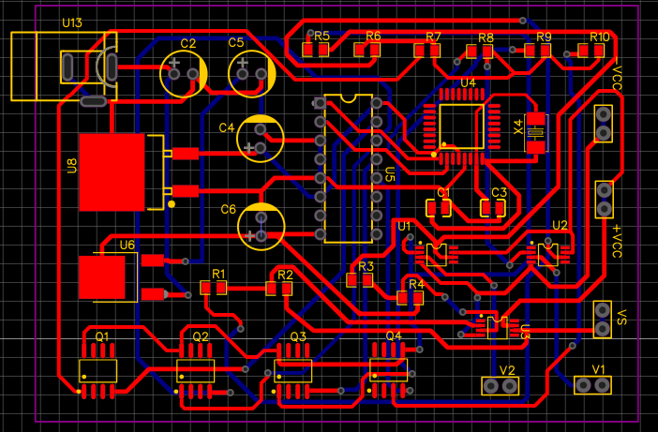
Conclusion :
In this chapter, we completed our project by designing the schematic, manufacturing the electronic board, assembling the components, and performing the tests. The results show that the circuit works properly and meets the set objectives.

Conclusion :
This project aimed to design and implement a programmable-gain instrumentation amplifier based on three OP07 operational amplifiers in SMD packages. The circuit was designed to offer precision, stability, and compactness through the integration of components such as precision resistors, MOSFETs, a decoder (type 74HC138), and an ATmega328P microcontroller. Initially, the design was implemented using SMD packages to meet miniaturization requirements. However, due to the limited availability of certain SMD components, a functional version of the project was developed using standard through-hole components. The developed system features a programmable gain, allowing automatic switching between different gain levels depending on the measured voltage. This functionality makes the amplifier more flexible and adaptable to signals of varying amplitudes, enhances measurement accuracy, reduces noise, and facilitates use in various applications requiring variable sensitivity. This project therefore combines theoretical aspects (gain analysis, component selection) with practical implementation (wiring, Arduino programming, simulation). This work provides a solid foundation for future applications requiring an intelligent, adaptable, and reliable amplifier, and it can be easily improved or further miniaturized through the use of more specialized components.

Bibliographic reference:
[1] Sedra, A. S., & Smith, K. C. (2020). Microelectronic Circuits (8th ed.). Oxford University Press.
[2] Horowitz, P., & Hill, W. (2015). The Art of Electronics (3rd ed.). Cambridge University Press.
[3] Franco, S. (2014). Design with Operational Amplifiers and Analog Integrated Circuits (4th ed.). McGraw-Hill.
[4] Kester, W. (2005). Instrumentation Amplifiers. Analog Devices.
[5]Carr, J. J. (2001). Sensors and Circuits. Newnes.
[6] Dutoit, T. (2012). Instrumentation et capteurs. Dunod.
[7] Ott, H. W. (2011). Electromagnetic Compatibility Engineering. Wiley.
[8] : https://www.ultralibrarian.com/2023/03/16/atmega328p-pinout-architecture-and-application-ulc
[9] : https://www.analog.com/media/en/technical-documentation/data-sheets/op07.pdf
[10] : https://www.mouser.com/datasheet/2/308/74hc138.rev1-289073.pdf
[11] https://www.alldatasheet.com/datasheet-pdf/view/88238/IRF/IRL540NS.html
[12] : https://www.alldatasheet.com/datasheet-pdf/view/69437/KEC/7805.html
[13] : https://www.alldatasheet.com/datasheet-pdf/pdf/888519/SEMTECH_ELEC/7808.html
[14]: http://www.elektronique.fr/logiciels/proteus.php.

